- Go to https://link.entourageyearbooks.com/index.asp? and type in Essex Fells in the search bar

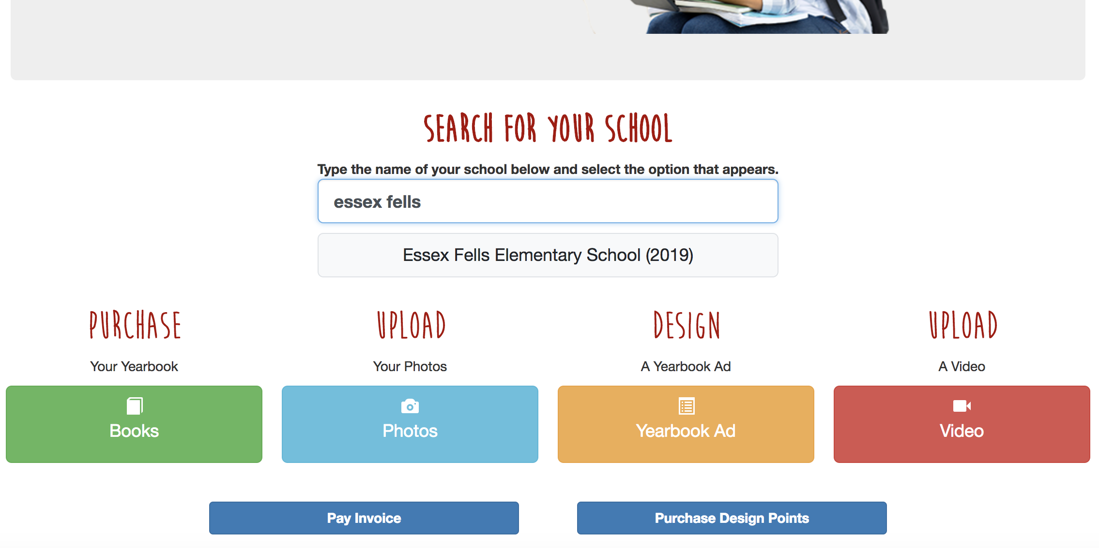

- Click on Essex Fells Elementary School (2019)
- This will take you to the home page. To upload photos click on the Photos button.
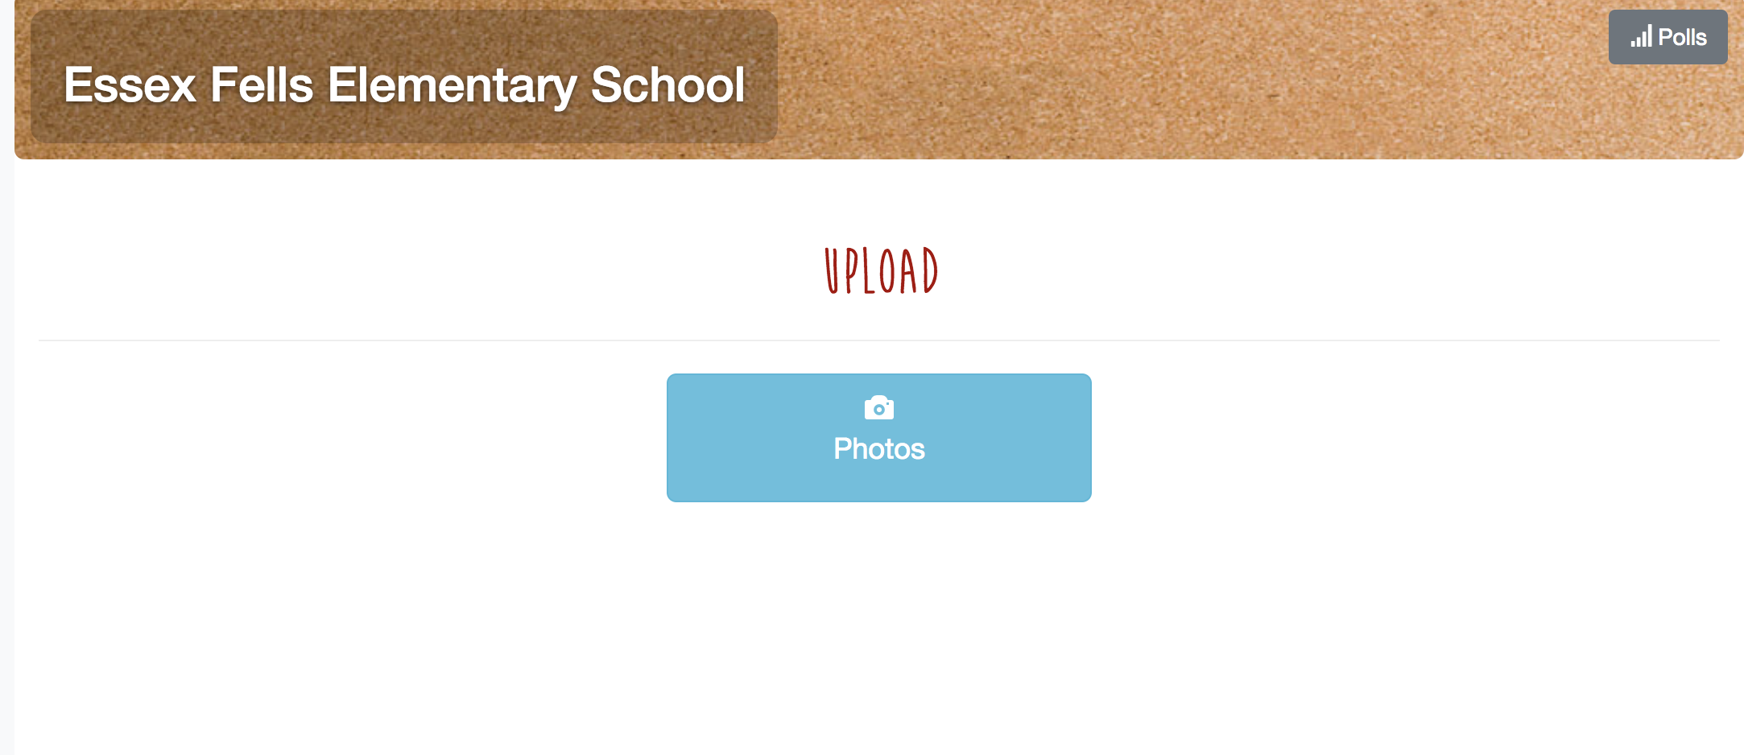

- You will then need to register using an email address.

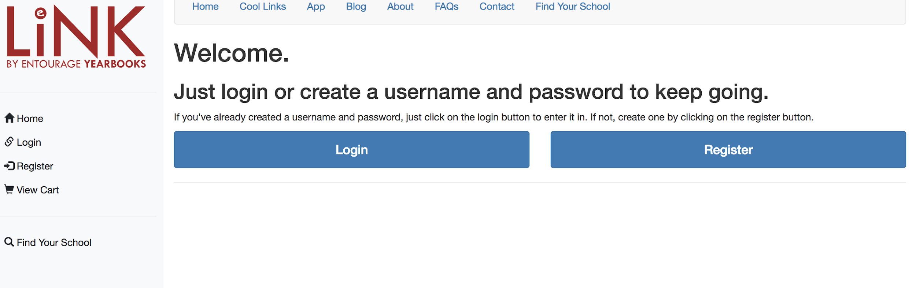

- Once you register, you will be asked for a password to upload pictures to the site. The password is: efs

- Now you are able to upload pictures. Choose a category to upload photos into. If you do not see an appropriate category, feel free to add a new one!

- Click “SELECT FILES” and select the photos you wish to upload. To select more than one photo at a time:
  - If you are using a Mac, hold down the command key and select multiple photos
  - If you are using a PC, hold down the control key and select multiple photos.

- Then click Open.

- Once you have all photos that you wish to upload selected, click “UPLOAD FILES”

- To finalize your upload, click Done on the bottom of the next screen.

**If you have any questions please contact Sara Christopher at schristopher@efsk-6.org

